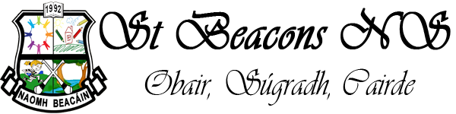Principal: Thomas O’Brien
Deputy Principal: Imelda Geraghty
MULLINAVAT,
CO. KILKENNY.
Telephone: 051-898442
The following is the school calendar for the year 2022-23

SEPTEMBER: Thursday 1st School re-opens
Thursday 15th – Staff Meeting (all children finish at 1.45p.m.)

OCTOBER: October 31st - Nov. 4th - Mid Term

NOVEMBER: Monday 7th - School re-opens
Wed. 16th & Thurs. 17th - Parent/Teacher Meetings
(children will go home at 2.30 p.m. on both days).

DECEMBER: Wednesday 21st - Christmas Holidays

JANUARY: Thursday 5th – School re-opens
Thursday 19th – Staff Meeting (all children finish at 1.45pm.)

FEBRUARY: Monday 6th: Public Holiday
Thursday 16th & Friday 17th – Mid Term

MARCH: Tuesday 7th - First Confession
Friday 17th St. Patrick’s Day
Fri 31st Easter Holidays

APRIL: Monday 17th – School re-opens

MAY: Monday 2nd – Public Holiday
Saturday 6th - First Holy Communion
Thursday 18th – Staff Meeting (all children finish at 1.45p.m.)

JUNE: Monday 5th - Public Holiday
Tuesday 6th – School Holiday
Tuesday 27th - Summer Holidays

Please note that Dept of Education and Skills have informed all schools that whole staff training will take place during the school year 2022-23. This will help schools to implement The New Primary Language Curriculum. The school will inform parents/guardians of any planned closure/s when notified by Department of Education and Skills during Term 1 of the school year 2022-23.

Dates for the sacrament of Confirmation have not yet been notified to Primary schools in Ossory for 2023.Parents/Guardians will be notified as soon as dates are made available.

