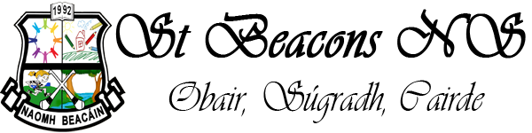Principal: Thomas O’Brien
Acting Deputy Principal: Mary Maher
MULLINAVAT,
CO. KILKENNY.
Telephone: 051-898442
The following is the school calendar for the year 2023-24

AUGUST: Thursday 31st School re-opens

SEPTEMBER: Thursday 14th – Staff Meeting (all children finish at 1.45p.m.)

OCTOBER: October 30th - Nov. 3rd - Mid Term

NOVEMBER: Monday 6th - School re-opens
Wed. 22nd & Thurs. 23rd - Parent/Teacher Meetings
(children will go home at 2.30 p.m. on both days).

DECEMBER: Friday 8th – School Holiday
Friday 22nd - Christmas Holidays

JANUARY: Monday 8th – School re-opens
Thursday 25th – Staff Meeting (all children finish at 1.45pm.)

FEBRUARY: Monday 5th - Public Holiday
Thursday 15th & Friday 16th – Mid Term

MARCH: Tuesday 5th - First Confession
Monday 18th – Public Holiday
Fri 22nd - Easter Holidays

APRIL: Monday 8th – School re-opens

MAY: Friday 3rd – School Holiday
Monday 6th – Public Holiday
Saturday 11th -First Holy Communion
Thursday 16th – Staff Meeting (all children finish at 1.45p.m.)

JUNE: Monday 3rd - Public Holiday
Wednesday 26th - Summer Holidays

Please note that Dept of Education and Skills have informed all schools that whole staff training will take place during the school year 2023-24. This will help schools to implement The New Primary Language Curriculum. The school will inform parents/guardians of any planned closure/s in due course.

